**Project 3**

**Project Title: E-commerce data analysis**

**Dataset:** <https://www.kaggle.com/datasets/hassaneskikri/fictional-e-commerce-sales-data>

**Tasks:**

**1. Evaluation of the Performance of each category with respect to sold and revenue.**

**2.Analyze the Refunded data for different Categories.**

**3.Analyze the revenue by month.**

**4.Analyze the revenue by Payment type.**

**5.Analyze the quantity by order status**

**Data Exploration:**

Dataset consists of columns are

* Customer ID
* Order date
* Order ID
* Order status
* Payment type
* Product category
* Product ID
* Quantity
* Total amount
* Unit price

**Key Metrics:**

Revenue – 7.63 million

Product count – 10000 products

Total sold quantity – 30097 products

**1.Evaluation of the Performance of each category with respect to sold and revenue**

**Sold by category**

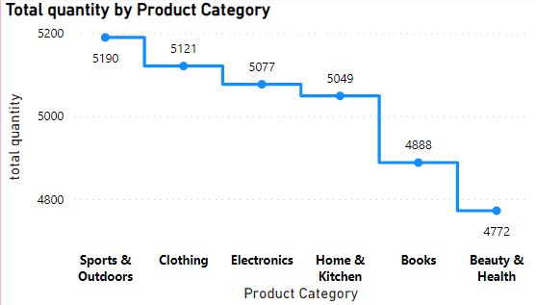

**Insights:**

* Sports and outdoors products are sold high of 5190 products
* Electronics and home & Kitchen Products are sold in medium of 5077 and 5049 products
* Beauty and health products are sold low of 4772 products

**Revenue By Category**

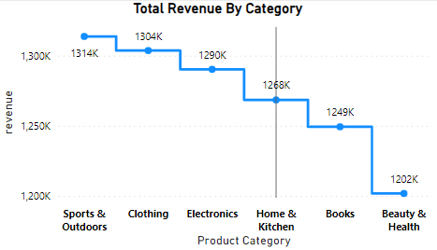

**Insights:**

* Sports & outdoors has the highest revenue of 1314K
* Beauty & Health has the lowest revenue of 1202K

**2.Analyze the Refunded data for different Categories**

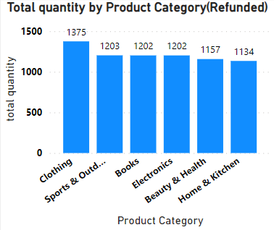

**Insights:**

* Clothing category got most products refunded (1375)
* Books and electronics are medium refunded (1202)
* Home & kitchen products are less refunded (1134)

**3.Analyze the revenue by month**

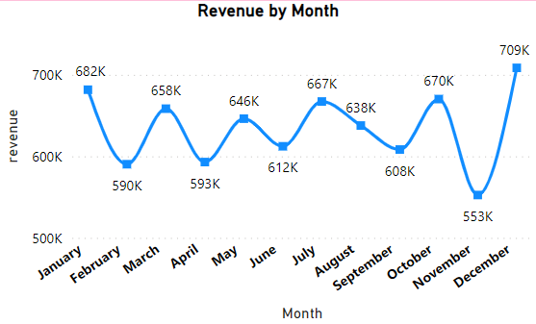

**Insights:**

* December month has the highest revenue of 709K
* November month has the lowest revenue of 553K

**4.Analyze the revenue by Payment type**

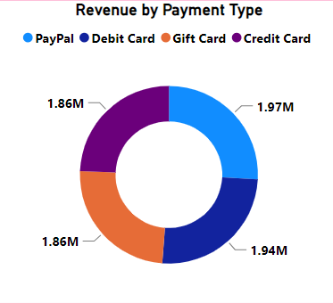

**Insights:**

* PayPal - 1.97 million
* Debit card - 1.94 million
* Gift cards - 1.86 million
* Credit card - 1.86 million

**5.Analyze the quantity by order status**

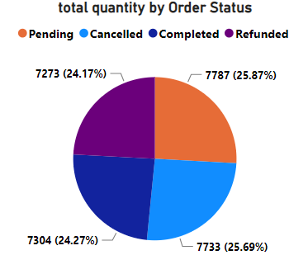

**Insights:**

* Pending orders are 7787
* Cancelled orders are 7733
* Completed orders are 7304
* Refunded orders are 7273